Using console parameters and strings

Please complete all the tasks using either Pseudocode or Flowcharts and attach a screenshot of your completed algorithm and code.

**Student ID**: Click or tap here to enter text.

**Full Name**: Click or tap here to enter text.

# Tasks

1. Develop an Algorithm using either Pseudocode or a Flowchart, to find a string within another and display where it is located.
   1. This algorithm may use the python standard library methods (such as *str.find()*)
   2. It must accept 2 console parameters from the user
      1. The first parameter is a sentence or long set of text
      2. The second parameter is a value to search for
   3. Ensure that the length of the first is not greater than the second
      1. If its longer, display an error message to the console and exit.
   4. Search the first parameter for the second parameters value.
   5. Output its location to console.
   6. **Attach a screenshot of this algorithm below**



Continued next page

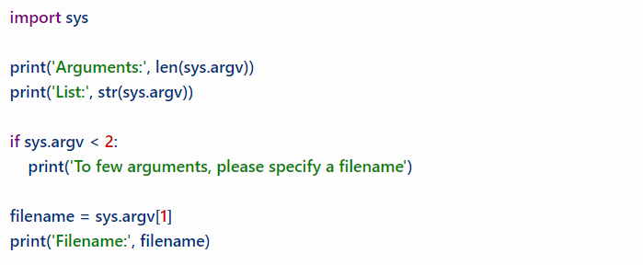

1. Given the above code and your algorithm developed above. Build a python application that implements the above task requirements. **Attach a screenshot of your code below.**



Continued next page

1. Modify your code developed above to also display how many words are in the inputted sentence. **Attach a screenshot of your modified code bellow.**

